CS 255 System Design Documen

This template lays out all the different sections that you need to complete for Project Two. Each section has guidance to prompt your thinking. You will need to continually reference the interview transcript as you work to make sure that you are addressing your client’s needs. There is no required length for the final document. Instead the goal is to complete each section based on what your client’s needs are. Remove this note when you are finished, and replace all bracketed text with the relevant information.

UML Diagrams

UML Use Case Diagram
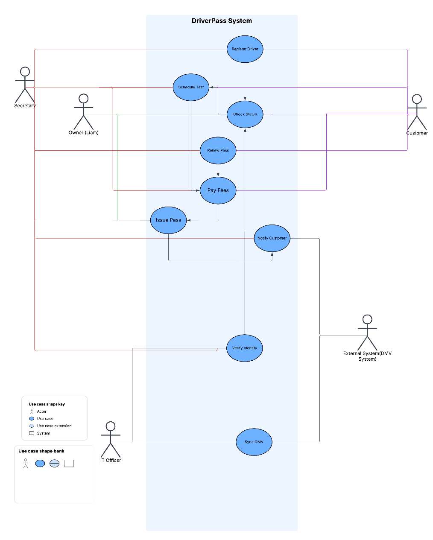

UML Activity Diagrams

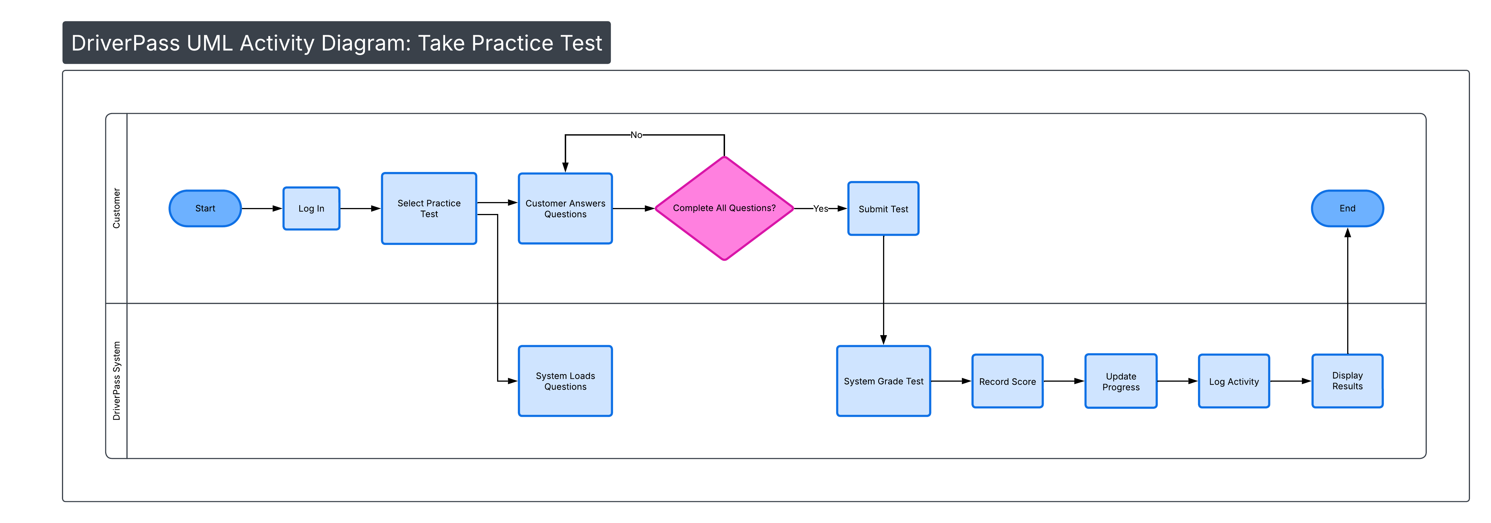

UML Sequence Diagram
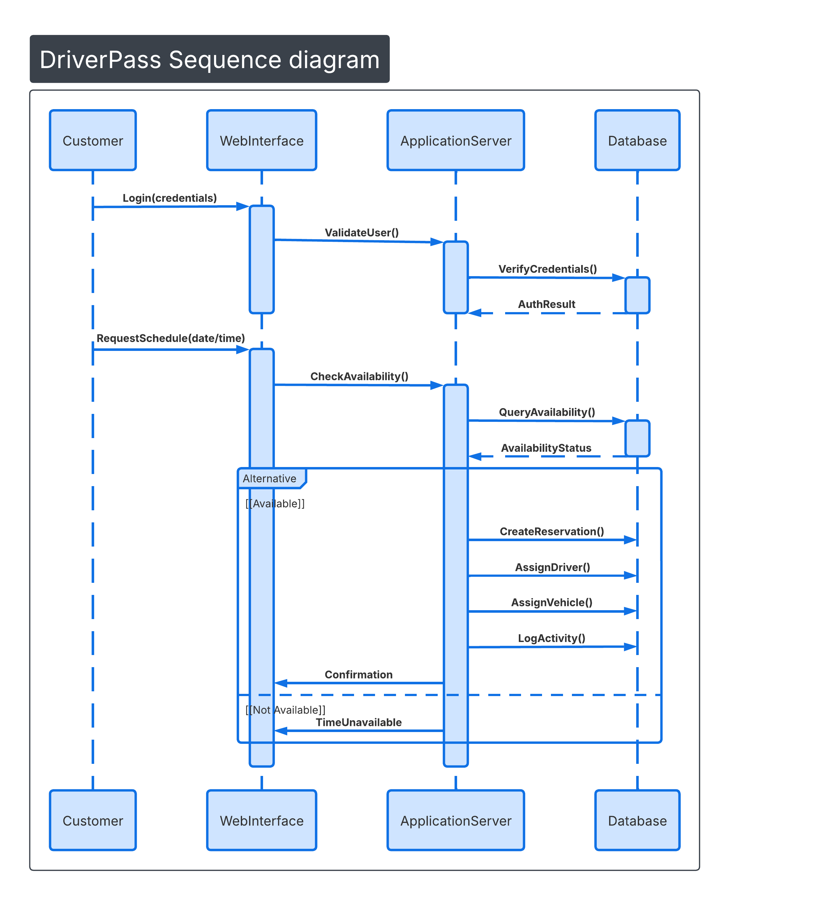

UML Class Diagram
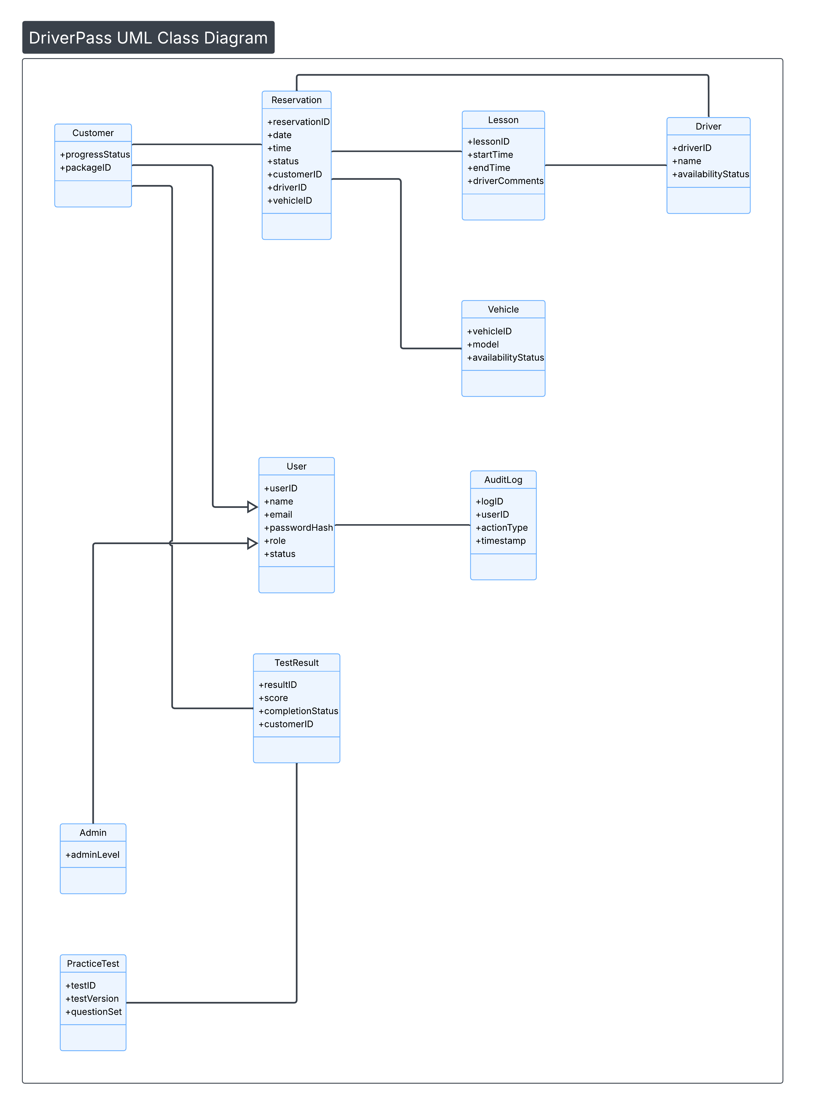

Technical Requirements
The DriverPass system will operate as a cloud-hosted, web-based application designed to support online driver education, lesson scheduling, practice testing, and administrative oversight. The technical architecture must ensure secure access, reliable performance, data integrity, and scalability to support both current operations and future expansion. Because DriverPass aims to improve DMV test success rates through structured preparation tools, the system must provide a stable and responsive platform capable of supporting multiple concurrent users.

From a hardware standpoint, the system will rely entirely on cloud-based server infrastructure rather than on-premises equipment. This approach reduces internal IT maintenance while providing scalability and high availability. The hosting environment must supply sufficient processing power, storage, and memory to manage authentication, scheduling transactions, practice test grading, lesson documentation, and reporting functions. End users will access the system through modern web browsers on internet-connected devices, including desktops and mobile devices.

The software architecture will include a centralized relational database to store user accounts, reservations, lessons, test results, packages, and audit logs. The database must enforce referential integrity to maintain consistency between related entities such as Customers, Reservations, Lessons, Drivers, and Practice Tests. A web application framework will manage business logic, including scheduling workflows, grading processes, and role-based access control.

Security is a foundational requirement. All users must authenticate using secure credentials, and access must be governed by role-based authorization. Data transmitted between users and the system must be encrypted using secure protocols. Passwords must be stored using hashing mechanisms, and repeated failed login attempts must trigger account protection measures. The system must also maintain audit logs to track critical actions such as reservation changes and lesson updates.

Performance requirements mandate that the system support concurrent users without significant degradation in response time. Scheduling actions, test submissions, and report generation must process with minimal latency. System updates should be implemented with minimal downtime to preserve availability.

Finally, the architecture must support scalability and adaptability. Administrative users must be able to enable or disable training packages without modifying source code, and the system must accommodate updates to DMV testing standards. External integration with DMV systems is limited to receiving updates, and payment processing will be handled securely by a third-party provider.

Overall, this technical framework ensures that the DriverPass system is secure, efficient, and scalable while aligning with the client’s operational goals and long-term growth strategy.

